**WMN Project 2024**

Topic: Understanding and Implementing 802.11n/ac (OFDM) in MATLAB

By,

Name: C.P.Sindhu

SRN: PES1UG21EC071

Sem-Sec: 6th –‘B’

Contents

|  |  |
| --- | --- |
| Sl. No. | Topics |
| 1. | About 802.11n and 802.11ac IEEE standards |
| 2. | About operating modes in 802.11n |
| 3. | About SGI and MCS |
| 4. | Implementation with .m files |
| 5. | Output screenshots for different cases |
| 6. | Conclusion and References |

IEEE 802.11n

The **Wi-Fi 4** ([802.11n](https://wikipedia.org/wiki/IEEE_802.11n-2009)) standard for Wi-Fi networks was approved by the IEEE ([Institute of Electrical and Electronics Engineers](https://wikipedia.org/wiki/Institute_of_Electrical_and_Electronics_Engineers)) on September 11, 2009.

The basis of the **802.11n** standard:

* Increased data transfer rate
* Increased network coverage
* Increased reliability of signal transmission
* Increased channel bandwidth

One of the highlights of the 802.11n standard is **support for MIMO** (Multiple-Input Multiple-Output) technology.

O MIMO technology enables simultaneous reception/transmission of multiple data streams via multiple antennas instead of a single antenna.

O The 802.11n standard defines different 'MxN' antenna configurations from '1x1' to '4x4' (the most common today are '3x3' or '2x3' configurations). The first number (M) defines the number of transmitting antennas (T), and the second number (N) defines the number of receiving antennas (R). For example, an access point with two transmitting and three receiving antennas is a '2x3' (or 2T3R) MIMO device.

However, *the use of multiple antennas alone does not increase the data rate or range expansion*. The main thing in 802.11n devices is that they implement an improved signal processing method, which determines the algorithm of the MIMO device when using multiple antennas.

Another additional feature of 802.11n is the increase in **channel width from 20 to 40 MHz.**

802.11n networks can **operate at 2.4 GHz and 5 GHz.**

IEEE 802.11ac

The basis of IEEE 802.11ac are:

* Wireless traffic operation takes place in the 5 GHz frequency band
* Increased speed and performance of the wireless data network
* Increased channel width
* Increased number of spatial streams
* New and more efficient signal modulation
* Multi-User MIMO technology support
* Beamforming technology support

**USE OF THE 5 GHZ FREQUENCY BAND**

The [802.11ac](https://wikipedia.org/wiki/IEEE_802.11ac-2013) wireless standard uses only the 5 GHz frequency band .

Due to the large number of devices operating in the 2.4 GHz band, the signal in the 5 GHz band is less susceptible to various types of interference. The use of the 5 GHz band provides a more free radio spectrum, resulting in a more stable and faster connection.

The **802.11ac** standard declares a maximum theoretical **connection speed of up to 7 Gbps.**

It has become possible to significantly increase the data transfer rate by **increasing the channel width to 80 MHz,** increasing spatial streams, and supporting the **new modulation 256-QAM.** *(optionally the channel width can be extended to 160 MHz)*

Twice the channel width (compared to **802.11n**, which uses a channel width of up to 40 MHz) results in higher data transfer rates and improved throughput.

**INCREASED THE NUMBER OF SPATIAL STREAMS**

The previous **802.11n** standard allowed for up to 4 spatial streams, while **802.11ac** has increased this number to 8.

**SUPPORT FOR MU-MIMO TECHNOLOGY**

The **802.11ac** standard significantly improves this situation. **Multi-User Multiple-Input**, **Multiple-Output** (**MU-MIMO**) technology has been implemented within the standard.

[MU-MIMO](https://wikipedia.org/wiki/Multi-user_MIMO) creates a multithreaded transmission channel in which other devices do not wait their turn.

**MU-MIMO-enabled** devices can simultaneously transmit up to four data streams (up to four clients). This enables more efficient use of the wireless network and reduces the latency that occurs when the number of clients in the network increases significantly.

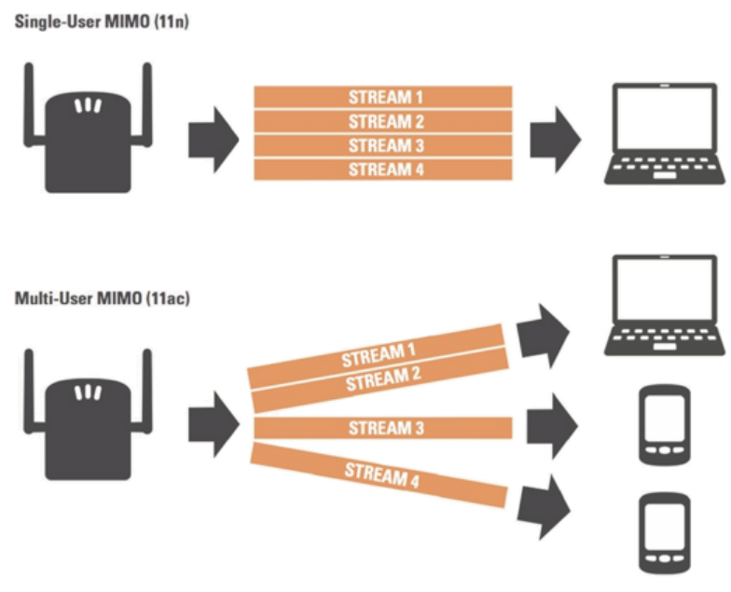

Figure : Difference between MIMO used in 802.11n and MU-MIMO used in 802.11ac

Operating Modes

**802.11N OPERATING MODES**

There are three modes of **802.11n** operation: **HT**, **Non-HT** and **HT Mixed**.

Let's take a closer look at each of the modes.

1. **High throughput HT mode**

**802.11n** access points use **High Throughput (HT) mode**, also known as 'clean' mode (**Greenfield mode**), which assumes that no **802.11b/g** devices using the same bandwidth are in operation nearby (in the coverage area). If such devices exist in the coverage area, they will not communicate with an **802.11n** access point. Therefore, only **802.11n** clients are allowed in this mode to take advantage of the increased speed and range provided by **802.11n**.

1. **Low-capacity mode Non-HT**

An **802.11n** access point using **Non-HT mode** (also known as a legacy mode) sends all frames in **802.11b/g** format so that legacy stations can understand them. In this mode, the access point must use a channel width of 20 MHz and will not take advantage of **802.11n**. Note that an **802.11n** access point using Non-HT mode will not provide high performance. With this mode, data is transmitted at a speed supported by the slowest device.

1. **High throughput HT Mixed mode**

In this mode, enhancements to the **802.11n** standard can be used simultaneously with existing **802.11b/g** stations. **HT Mixed mode** will provide backward compatibility between devices, but **802.11n** devices will receive a reduction in throughput. In this mode, the **802.11n** access point will recognize the old clients and use a lower data rate while the old device is transmitting and receiving.

SGI and MCS

* The **SGI** (Short [Guard Interval](https://wikipedia.org/wiki/Guard_interval)) defines the time interval between transmitted symbols (the smallest unit of data transmitted at one time). This interval helps data reception avoid delays due to [Inter-Symbol Interference](https://wikipedia.org/wiki/Intersymbol_interference) (**ISI**) and overcome echoes (reflection of sound waves).
* Shorter intervals would lead to more interference and reduced throughput, while longer intervals can lead to unwanted downtime in the wireless environment. Short guard interval (**SGI**) can increase data rates
* **MCS** values 0 to 31 define the type of modulation and coding schemes to be used for all streams. **MCS** values 32 to 77 describe mixed combinations that can be used for modulations of two to four spatial streams

Implementation

On opening 802.11n/ac OFDM app

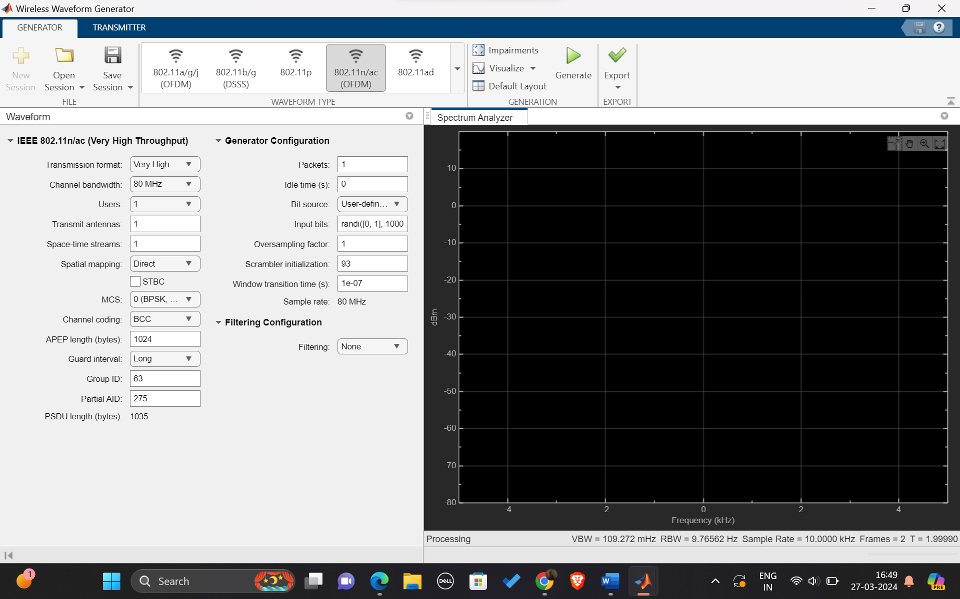

Drive link: <https://drive.google.com/drive/folders/1Z38ryW2znaU9rVTSXgeey68_IYHedXgB?usp=sharing>

For Very High Throughput:

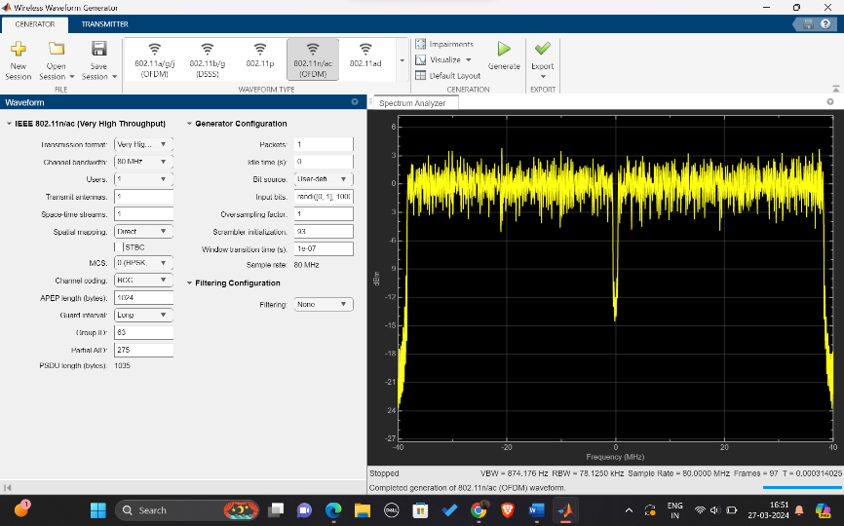Case 1:

* Bandwidth = 80Mhz
* Transmit antennas = 1
* MCS = 0(BPSK, ½ rate)
* Channel coding = BCC
* Input bits = randi([0, 1], 1000, 1)
* Oversampling Factor =1

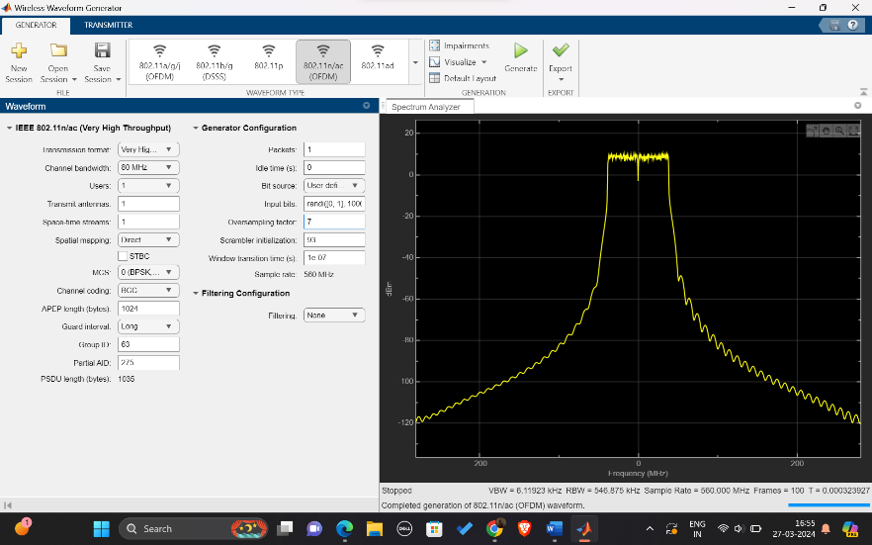Case 2:

* Change oversampling factor to 7

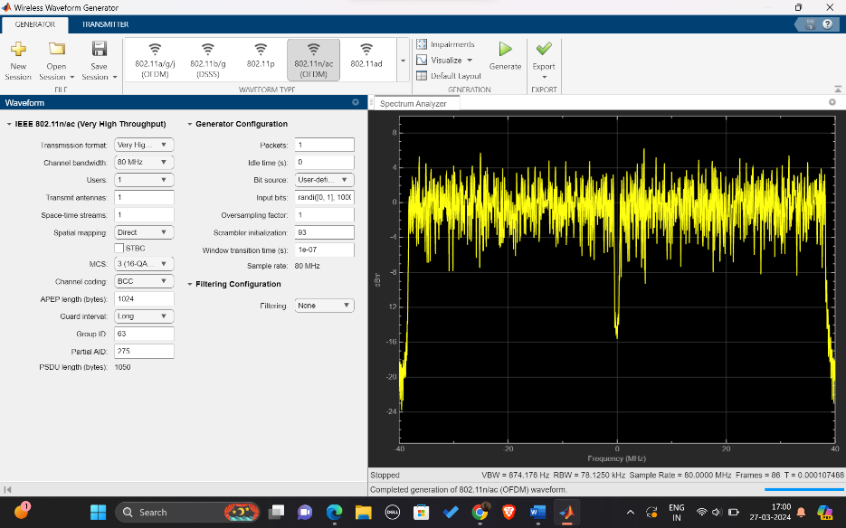Case 3:

* MCS = 3(16-QAM, ½ rate)
* Change MCS to 3

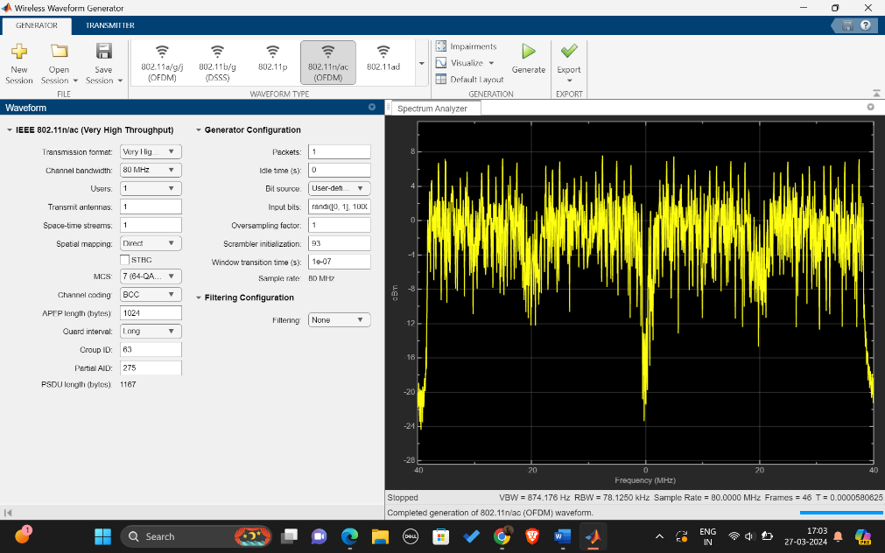Case 4:

* MCS = 64 QAM, 5/6 rate
* Change MCS to 7

For High Throughput:

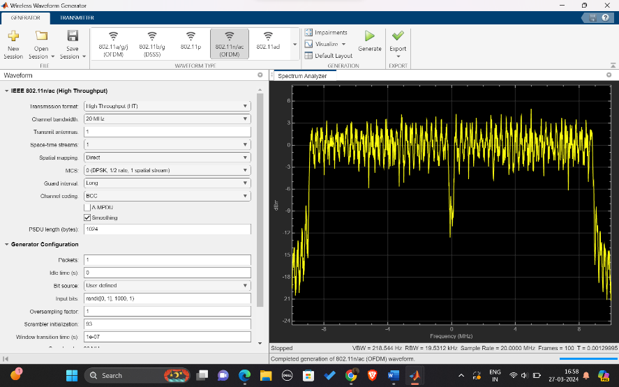Case 1:

* Transmission Format = High Throughput
* Bandwidth = 20MHz
* MCS = 0(BPSK, ½ rate)

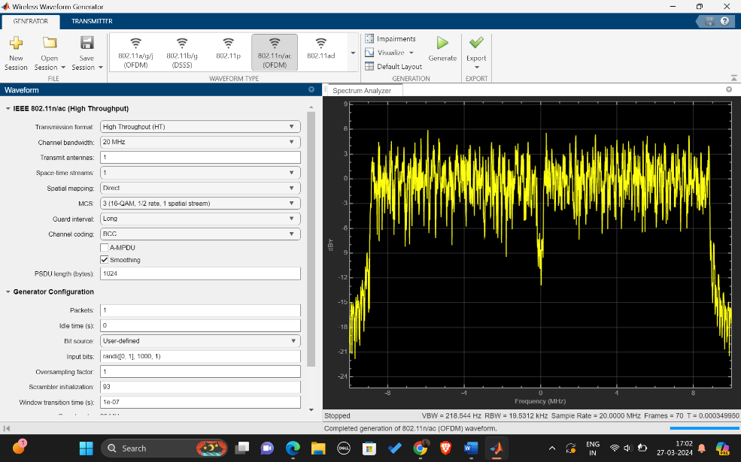Case 2:

* MCS = 3(16 QAM, ½ rate)
* Change MCS to 3

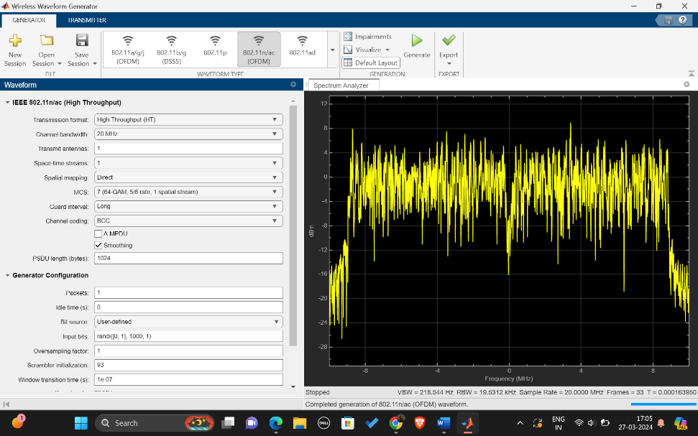Case 3:

* MCS = 64 QAM, 5/6 rate
* Change MCS to 7

For Non-High Throughput:

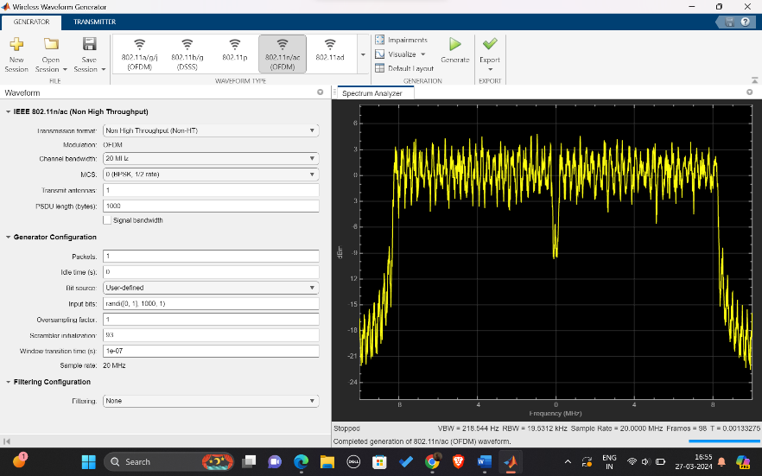Case 1:

* Transmission Format = Not very high

throughput

* Modulation = OFDM
* Bandwidth = 20Mhz
* MCS = 0(BPSK, ½ rate)

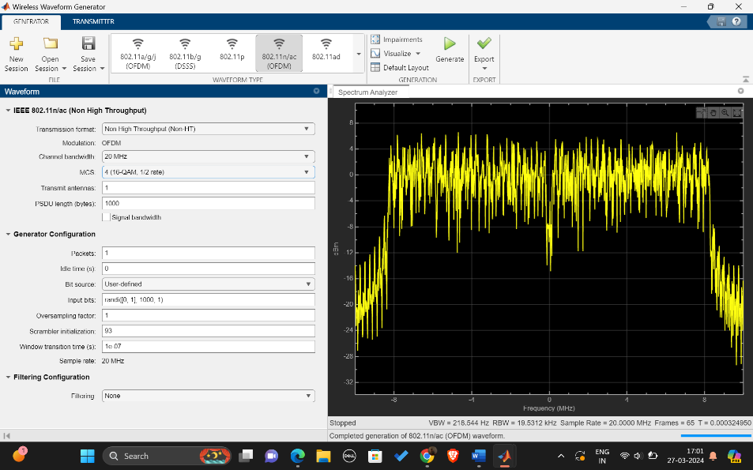Case 2:

* MCS = 4(16 QAM, ½ rate)
* Change MCS to 4

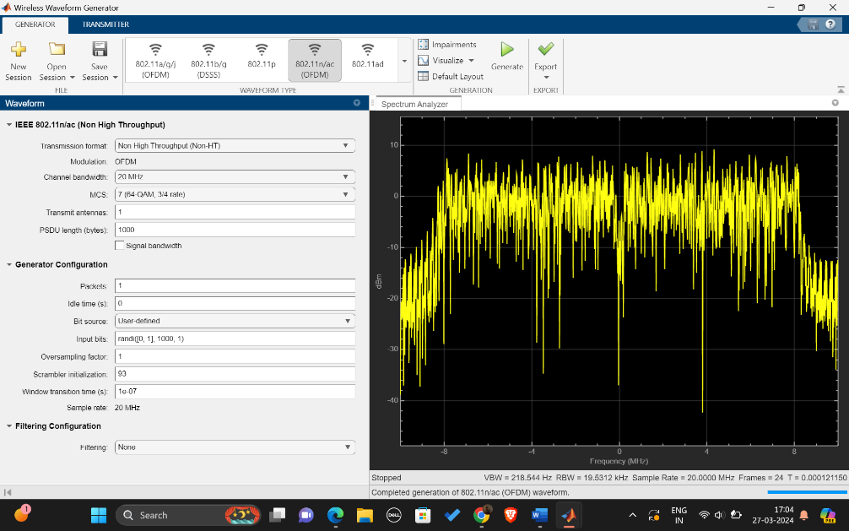Case 3:

* MCS = 64 QAM, 3/4 rate
* Change MCS to 7

**Conclusions:**

We understood the basis and different characteristics of IEEE 802.11n and 802.11ac.

With the understanding we successfully simulated the WiFi standards for different cases on MATLAB.

**References:**

🡪 <https://docs.keenetic.com/eaeu/giga/kn-1010/en/20210-10--what-you-need-to-know-about-wi-fi-4--ieee-802-11n-.html>

🡪 <https://docs.keenetic.com/eaeu/giga/kn-1010/en/20209-9--what-you-need-to-know-about-wi-fi-5--ieee-802-11ac-.html>